Foreword:

It was the last day, or rather, night, of October 2005. Only a week to go before I submit my CFA!!! The realization sunk in, and left me numb, nervous and alarmed. So much so that I peeled myself off the bed, turned on the light and pulled out the sheaf of papers in which I had scrawled some ideas, and settled down to the daunting task ahead of me. In fact, I was so petrified, I didn’t realize that I had neglected to open the windows. It was a rather windy night (averaging at just under 8 miles per hour), and I could have enjoyed the moisture, but that’s not what I am worried about now. You see, I had switched on the all out!, and as you all may know already, this is a mosquito repellent, containing 1.6% (by weight) of prallethrin. Not one of the best compounds to wallow in.

All night, I sat glued to my desk, working away industriously, but in vain. Stealthily, the dawn of 1st November crept over the murky skies. The colourful fireworks of Deepavali did nothing to lighten my mood. Morose and disgruntled, the day was spent in listless looks and restless rambles. Finally, after whiling away the day, once again, I burned the midnight oil. But this time, I was a wee bit more intelligent. I threw open the windows and drew the curtains as well. It was a trifle more windy too, but that did nothing to bring me enlightenment. Haggard and defeated, I dragged myself to the institute, and sleep-sat through the classes.

Well, it’s the 6th of November today, and I am still clueless about my CFA. Wonder what I shall submit tomorrow… On hindsight, it would have been way better if the prallethrin levels in my room had reached potent limits, and I could have a medical certificate to palm off as an excuse. Hmmm… Wonder what value it reached on the first night. Did my opening the windows have any effect? I guess my position relative to the vapourizer is an important factor to consider too. Spatial and temporal variation of prallethrin levels need to be determined if I need to quantify my chances of getting my hands on an MC.

Oh well, looks like I do have a topic after all…

My problem definition:

- How did the concentration of prallethrin vary with time?
- What was the spatial distribution of prallethrin?
- Did the concentration reach toxic levels?

Mode of approach:

As regards the first case, the situation is akin to a fedbatch operation. I shall balance prallethrin in the “reactor”, and obtain the concentration as a function of time. The simplifying assumptions I shall make, as well as the motives for imposing them, are listed below:

- The room has no furniture. This makes assumption #2 more valid, and eliminates any need for corrections accounting for spatial irregularities.
- The mosquitoes are uniformly distributed in the room. This is a rather questionable assumption, since the probability of finding mosquitoes above a certain height (~ 1m) in a room is negligible. However, this simplifies the analysis considerably, since N (number of mosquitoes) can be taken out of space integrals.
- The prallethrin is uniformly distributed in space. That is, I choose to neglect spatial variation, since efficient “mixing” occurs due to the presence of a fan. Since I am attempting to find variation with respect to time, I have assumed this uniformity.
- Effects due to movement of air are negligible. While the presence of a fan simplifies the situation by validating assumption #3, it introduces non-uniformity in the form of air movement, which will have a bearing on flux of prallethrin and mosquitoes through any plane. However, since I am at a loss to quantify these effects, I choose to neglect them.

The second case of open windows is analogous to a chemostat, and hence, I shall analyze the system when it has attained steady state, when the concentration of prallethrin and number of mosquitoes are constants. The additional assumptions involved are elucidated in that section.

Some basics:

- My room measures 11×10×10 (all in feet). That makes the volume of the room 29.7 m³.
- Normal breathing rate of a 20 year old female human is 17 breaths per minute. Volume inhaled per breath is 500 ml.
- All out! contains prallethrin, a pyrethroid ester, and toxic dose for mosquitoes is 0.0032 μg per insect. Lethal concentration for 50% death in rats is established to be 2630 mg/m³ .
- At a height of 25 feet above the ground (I live on the second floor), an average of 20 mosquitoes are present per room, without any repellent being used.

Symbols used:

Concentration of prallethrin | c
Initial number of mosquitoes | N₀
Toxic dosage for mosquitoes | d
Volume of my room | V
Tidal volume | V_{b}
Rate of breathing | k_{b}
Number of mosquitoes at time t | N
Residue degradation rate | k₂
Residue deposition rate | E
Rate of vapourization | k
Rate constant for photolysis | k_{p}

How does a change in c affect N?

To obtain the relationship between N and c, consider an infinitesimal time period dt, in which the change in N is dN. This is brought about by the change in c, dc. Clearly, dN is directly proportional to (V*dc)/d (the change in number of toxic doses), and is also dependent on the number of mosquitoes present at time t. This is something like a reaction between a live mosquito and prallethrin, with the product being a dead mosquito.

dN α N*V/d*dc

Additionally, there must be a non-unity probability that a mosquito, on encountering prallethrin, consumes it or not, which I denote by p. Despite extensive searches, I am unable to find its value, and hence am forced to assume that both the contingencies are equally probable, and hence p is assigned the value 0.5.

Therefore, dN=K*p*N*V/d*dc, where K is a parameter which describes the probabilty that a mosquito “meets” a dose of all out! (something like collision frequency), and through trial and error, a value of 2*10⁻⁵

Integration of this expression results in N=N₀*e^{-0.0928c} = 20* e^{-0.0928c} ------ 1

---plot 1
CASE 1: FED BATCH OPERATION

Considering the general equation for prallethrin,

Input rate + growth rate – output rate – consumption rate = rate of accumulation ------ 2

Input was only through vapourization from the refill. The vapourization rate, calculated from the experimental data, is 0.019 μg/min.

Growth rate was zero, as was the output rate.

Consumption of prallethrin was through four processes: mosquitoes ingested the compound, I inhaled it, there was deposition on the floor, and finally, there was degradation due to light (the light “ate” it).

The rate at which the mosquitoes consumed prallethrin is calculated indirectly from the number of mosquitoes which died, per unit time. This quantity, multiplied with the toxic dosage is the required rate of mosquito consumption.

As regards my contribution, it is simply the product of my rate of breathing, the volume of one breath (tidal volume) and the ambient concentration of prallethrin at that time.

Deposition on the floor accounts for about 2.5% of prallethrin vapourized, and the rate is given by (E/k)*(1- exp(-k*t)), as established by Matoba et al. This formula holds for a 0.9% solution, and a room of dimensions . Moreover, ventilation of some sort was provided. I have reason to take this formula as it is, qualitatively, since the loss due to ventilation is compensated by the lower concentration of the solution. Unfortunately, when this term is also considered, the solution of the equation becomes complex, and hence, I choose to neglect this. This is not very erroneous, since the amount of prallethrin deposited in the floor at the end of 12 hrs of vapourization is negligible, as calculated from the formula.

Pyrethroids undergo photolytic degradation, and since I had the tubelight on, this cannot be neglected. Due to absence of data, I shall assume that this is a first order reaction, with a half life of 25.9 /day.

Accumulation rate is the product of the volume of the room, and the rate of change of prallethrin concentration.

Plugging in the terms in eq 2, I obtain,

k-[V_{b}*k_{b}*c + (-dN/dt)*d + k_{p}*c + (E/k)*(1- exp(-kt))]= V(dc/dt) ------ 3

I am yet to quantify the rate of change of mosquitoes (dN/dt). This is simply the time derivative of eq 1, and is multiplied by –1, since the absolute value is required.

Therefore, absolute rate of change of mosquitoes = 1.856 (dc/dt)

Substituting this in eq 3, I get, 0.019- 8.51865*10⁻³ *c= 31.556 (dc/dt)

Solving this differential equation, I obtain the following concentration profile:

c= 2.23*(1- exp(-2.699*10⁻⁴*t)) ------ 4

---plot 2

CASE 2: CONTINUOUS OPERATION

Here, the number of mosquitoes N and the concentration of prallethrin c are invariant with time. I do not attempt to analyze the system before the establishment of steady state. I present two methods of analyses, one using spherical coordinates, the other employing cylindrical. In both the cases, the vapourizer is at the origin, and the values obtained at the end of the analysis is multiplied by a factor of 2, since in the actual scenario, prallethrin permeates through one half alone.

In the following section, I choose to neglect loss due to inhalation, photolysis and deposition, since this considerably complicates the equations.

Spherical coordinates:

Considering a differential element as shown, and realizing
that the pertinent equation is:

Flux in – flux out = rate of consumption due to mosquitoes

Hence, (4πr²c)_{r} – (4πr²c)_{r+Δr} = 4πr² (Δr)*(N/V)*p*d

4πr² (Δr) is the volume of the element, and this multiplied by (N/V), which is the number of mosquitoes per unit volume, yields the number of mosquitoes present in the element.

Dividing by Δr, and taking the limit Δr → 0,

d(cr²)/dr = 0.3367* cr² e^{-0.0928c}

Boundary condition is as follows:

c=0, at r= ∝

Approximating my room to a sphere, I get the equivalent radius as volume/(3*surface area), ie, r_{eq}= 1.547 m. Beyond this point, for all practical puposes, my room does not exist, and any larger r describes the ambient.

Therefore, 2*c vs r, where c is the concentration of prallethrin as described by eq , is the required spatial distribution. This equation is solved using CFD, and in the process of solving it, it is changed from an initial value problem to a boundary value one. The scale shown is arbitrary, and can NOT be used to obtain numerical values. Only the required trend may be observed. The graph between c and r is drawn below:

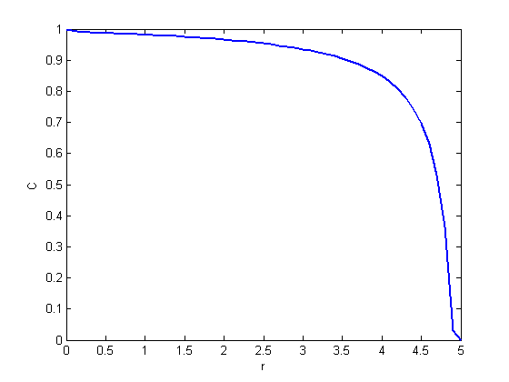
---plot 3
Cylindrical coordinates:

Following the same outline as earlier, with the modification that
r_{eq}= breadth/2.
The differential element is as shown, and the equation for mass
balance is,

(2πrl*c)_{r} - (2πrl*c)_{r+Δr} = (2πrl)* (Δr)* (N/V)*p*d

that is, d(cr)/dr = 0.3367* cr* e^{-0.0928c}
Using similar boundary conditions, the following profile is obtained.
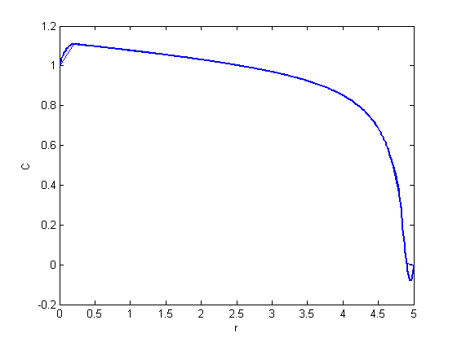
---plot 4

How close were my chances of wriggling out of this submission?

Since I have an accurate profile only for the first case of colsed windows, I can calculate the amount of prallethrin I had inhaled that night. This is simply [c*V_{b}*k_{b}]*dt, integrated from time 0 to time (60*8) mins. The quantity in parantheses is the amount of prallethrin inhaled per min.

Carrying out the integration, I have determined that I had inhaled 17.637 μg of prallethrin that night, an amount not capable of causing any harm (unfortunately!).

So, at the end of the day…

Plot 1 shows how the number of mosquitoes varies with concentration of prallethrin. As can be gathered from equation 1, there is an exponential decrease in N as c increases.

When the windows were closed, there was no outlet, and hence c increased with time t. This too is an exponential process described by equation 4, albeit not a rapid one. In fact, in the time interval of interest, it is nearly linear. It is in this case that it was more prallethrin was inhaled, since there was a build-up of the compound with time. The amount inhaled came out to be insignificant, at just under 20 μg.

In the second case, with open windows, the system was assumed to be at steady state. Since the differential equations were too complex to be solved through normal means, CFD (computational fluid dynamics) was employed. The plots are comparable, and go on to show that beyond r_{eq}, there is a steep decrease in c, as expected. They indicate that until a certain r, there is not any appreciable variation of c, though there is a decrease as one moves away from the source. There is not much to chose between the two coordinate systems, particularly in the absence of precise scales.

How this CFA could have been better…

- There are many errors in this analysis, as is obvious from the discrepancy in the concentration range in plot 1 and that in plot 2. This is clearly due to the assumptions made. Additionally, k is abnormally small, and this can be the cause of the low values obtained in all subsequent plots.
- Many assumptions have resulted in loss of generality, particularly the uniform mosquito distribution. Furthermore, absence of furniture is a questionable assumption. Some way of describing spatial distribution of mosquitoes, would have made the analysis more realistic.
- In the case of open windows, wind plays an important role, and when it blows, concentration profiles get disturbed. This perturbance is not accounted for.
- As is known already, 2.5% of vapourized prallethrin is deposited on the floor. This contribution has been omitted because it introduced complexity in the differential equations.

References

- http://www.who.int/whopes/quality/en/prallethrin_spec_eval_Nov_2004.pdf
- http://www.jstage.jst.go.jp/article/jpestics/29/4/313/_pdf
- http://www.wunderground.com/global/stations/43279.html
- http://www.kangmei.com/prallethrin.htm
- http://users.rcn.com/jkimball.ma.ultranet/BiologyPages/P/Pulmonary.html

Acknowledgements

I would like to place on record my sincere and profound gratitude to Dr. G. K. Suraish Kumar, without whose inspiring example, I would not have been motivated to carry out such an interesting exercise.

I would like to thank my friends Ms. Rekha Gupta and Ms. Vainatha Polasani, for their unfledging support and encouragement. Their comments and suggestions are immensely appreciated.

I owe Mr. Arnab Mukherjee a cartload of thanks for helping me solve the complex equations. Without his selfless efforts, I may not have had a plot to show at all!

Finally, I would like to thank the mosquitoes themselves, for cheerfully consenting to play a part in my CFA. May their tribe increase!

